***Advertising Campaign Project***

**Group Members:**

* Khawaja Abdullah (20K-0385)
* Sohaib Ashraf (20K-0488)
* Muhammad Shahzaib (20K-1067)
* Mohammad Basil Ali Khan (20K-0477)
* Abdul Ahad Shaikh (20K-0319)
* Syed Ali Jodat Naqvi (20K-0155)

**Task #1 - Planning Your Campaign**

**1. Product:**

Next Beverages

**2. Client Company:**

Cola Next

**3. Advertising Campaign Objective:**

To convey that Next Beverages is a local brand manufactured through high international standard processes.

**4. Primary and Secondary Markets:**

**Primary:**

* Geographically: Pakistani market (emphasizing the boycott of imported products)
* Business Segmentation**:** Fast Food businesses

**Secondary:**

* Demographically**:** Youth (Age 15-30)

**5. Advertising Budget:**

$5,000-$7,000

Converted to PKR: 900,000 PKR - 1,260,000 PKR

**Print Ad:**

* Local Magazine: $200-$500

*Converted to PKR: 36,000 PKR - 90,000 PKR*

* National Magazine: $1,000-$2,500

*Converted to PKR: 180,000 PKR - 450,000 PKR*

**Radio Ad:**

* Traditional advertising:
  + City: Karachi
  + Potential reach: 2 million listeners
  + Cost for 30 seconds of air time: $50-$100

*Converted to PKR: 9,000 PKR - 18,000 PKR*

* Streaming advertising:
  + Outlet: FM91
  + Circulation: Online streaming audience of 500,000
  + Minimum cost: $100-$200 per ad slot

*Converted to PKR: 18,000 PKR - 36,000 PKR*

**Billboard:**

* City: Lahore
* Type: Physical Billboard
* Cost: $300-$800 per month

*Converted to PKR: 54,000 PKR - 144,000 PKR*

**Television Commercial:**

* Primetime TV commercial: $500-$1,000 for a 30-second slot

*Converted to PKR: 90,000 PKR - 180,000 PKR.*

**Q. With the budget you were given, would running a television ad be an option for you to include in your campaign? Why or why not?**

With the budget allocated for the advertising campaign being $5,000-$7,000 (which converts to approximately 900,000 PKR - 1,260,000 PKR), running a television ad would be a consideration, but it might pose some challenges.

* **Cost of Television Ad:**
  + A 30-second television commercial during primetime on network TV typically costs $500-$1,000 (or approximately 90,000 PKR - 180,000 PKR).
* **Budget Constraints:**
  + Given the budget constraints, allocating a significant portion solely for a television ad might limit the flexibility to explore other advertising mediums effectively.
* **Effectiveness vs. Cost:**
  + While television ads can reach a wide audience, their effectiveness in terms of cost per impression needs to be evaluated against other mediums like radio, print, or digital advertising.
* **Alternative Options:**
  + Considering the target market (primarily fast-food businesses and youth), mediums like radio, digital streaming, and local magazine ads might offer more targeted and cost-effective options within the given budget.
* **Strategic Planning:**
  + To maximize the impact of the campaign within the budget, it may be prudent to focus on a mix of mediums that offer a balance between reach, targeting, and cost-effectiveness.
* **Final Decision:**
  + While running a television ad could potentially enhance the campaign's visibility, it might not be the most efficient use of the allocated budget. Therefore, a thorough analysis of alternatives and strategic planning would be necessary to determine the optimal mix of advertising mediums for the Next Beverages campaign.

**Q. Would you use social media as a part of your advertising campaign? Why or why not?**

Yes, incorporating social media into the advertising campaign for Next Beverages would be highly advisable for several reasons:

* **Target Audience Reach:** 
  + Social media platforms like Facebook, Instagram, and Twitter are frequented by the target demographic of youth aged 15-30. Leveraging these platforms allows the campaign to directly engage with and reach the intended audience.
* **Cost-Effectiveness:** 
  + Compared to traditional advertising mediums like television or print, social media advertising often offers lower costs and higher flexibility. With the allocated budget in mind, social media ads can provide significant exposure and engagement at a fraction of the cost of traditional methods.
* **Targeting Capabilities:** 
  + Social media platforms provide sophisticated targeting options, allowing advertisers to tailor their ads based on demographics, interests, behaviors, and even geographic location. This enables Next Beverages to precisely target its message to the desired audience segments, such as fast-food businesses and youth in specific regions of Pakistan.
* **Engagement and Interaction:** 
  + Social media facilitates two-way communication between brands and consumers. By fostering engagement through content, polls, contests, and interactive features, Next Beverages can build relationships with its audience, gather feedback, and create brand advocates.
* **Content Distribution:** 
  + Social media enables the distribution of various types of content, including videos, images, articles, and user-generated content. This versatility allows Next Beverages to showcase its products, convey its brand message effectively, and maintain a consistent presence in the digital space.
* **Measurable Results:** 
  + Social media advertising platforms provide robust analytics and reporting tools, allowing advertisers to track the performance of their campaigns in real-time. Metrics such as reach, engagement, clicks, conversions, and return on investment (ROI) can be monitored to assess the effectiveness of the advertising efforts and make data-driven optimizations.

**Q. What social media platform most closely matches your** primary **market? Why?**

For the primary market of Next Beverages, which includes fast-food businesses and the Pakistani market emphasizing the boycott of imported products, the social media platform that most closely matches these demographics and market characteristics would be Facebook.

* **Wide Audience Reach:** 
  + Facebook is the most popular social media platform in Pakistan, with a large and diverse user base spanning different age groups, including the youth demographic targeted by Next Beverages. This ensures that the brand's message can reach a significant portion of its primary market.
* **Business-Friendly Features**:
  + Facebook offers a range of features specifically designed for businesses, including business pages, advertising tools, and insights. This makes it easier for Next Beverages to establish a professional presence, engage with its target audience, and run targeted advertising campaigns tailored to the preferences and behaviors of fast-food businesses and Pakistani consumers.
* **Targeting Options:** 
  + Facebook provides robust targeting options that allow advertisers to reach specific demographics, interests, behaviors, and geographic locations. This precision targeting capability enables Next Beverages to tailor its ads to resonate with fast-food businesses and youth in Pakistan, ensuring that the message reaches those most likely to be interested in the product.
* **Engagement Opportunities:** 
  + Facebook offers various engagement features such as likes, comments, shares, and messenger, facilitating interaction between the brand and its audience. This enables Next Beverages to foster meaningful connections, gather feedback, and address customer inquiries or concerns directly, enhancing brand trust and loyalty.
* **Content Diversity:** 
  + Facebook supports a wide range of content formats, including text posts, images, videos, live streams, and stories. This versatility allows Next Beverages to showcase its products, share relevant industry news and tips, run contests or promotions, and deliver engaging content that resonates with its primary market.

**Project: Task #2**

**Part 1: Brainstorming and sketching**

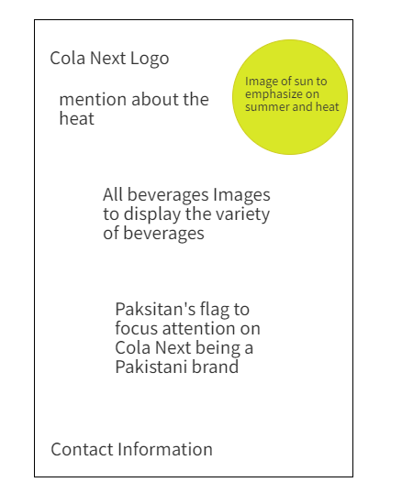

**Part 2 Print AD**

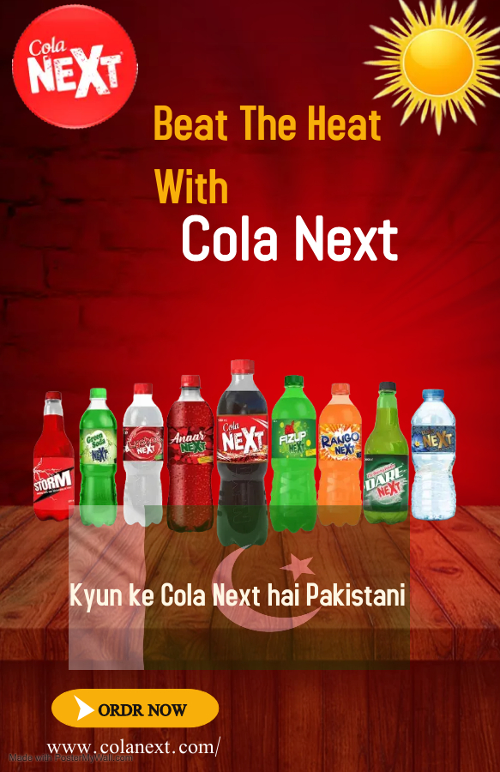

**Project: Task #3**

**Creating Digital & Social Media Content**

**■ Banner Ad**

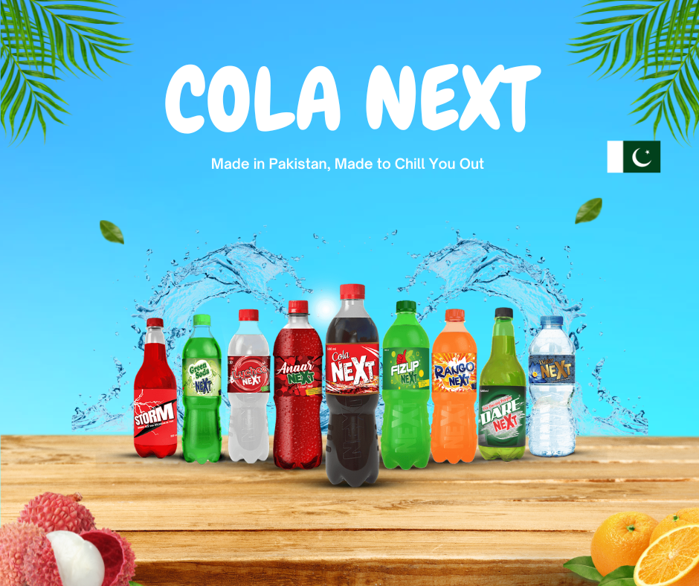

**■ Promotional Video**

**➢ Social Media Advertising (Choose any 1 platform)**

**■ Facebook Post**

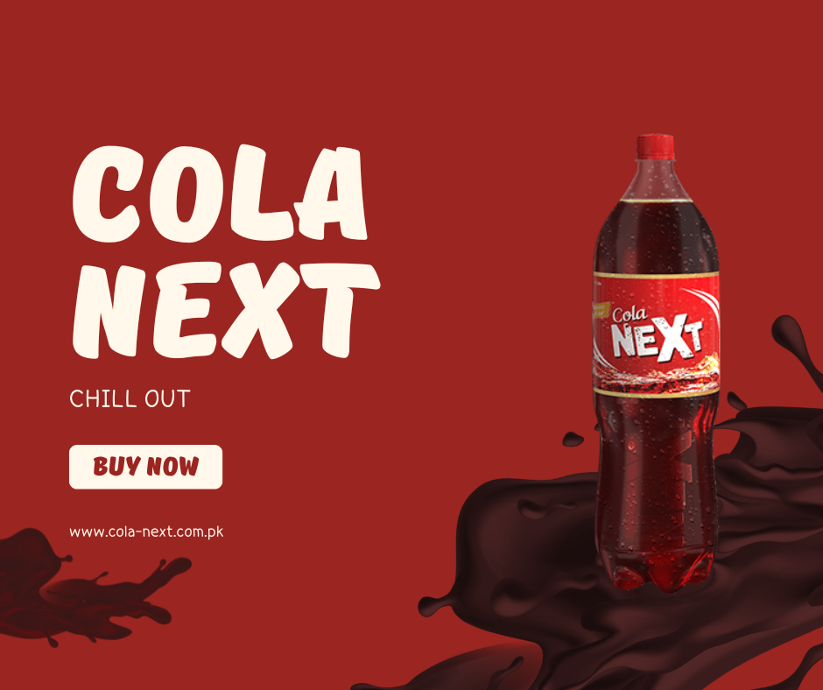

**PROJECT: TASK#4**

**Radio Script:**

**Attention Grabbing Opener (Sound Effect: Upbeat Pakistani music with a modern twist):**For example Hassan’s Rahim Joona would be an excellent candidate because of the “chill vibe” it offers to its listeners.

**Announcer (Energetic, youthful voice):** Are you tired of the same old fizzy drinks? Do you crave something refreshing, local, and made with international standards? Then try out our new set of Next flavours!! Kioke Next Best hai yarrrr!

**Major Content**

**Announcer:** Look no further than Next Beverages! We're a Pakistani brand proudly offering a variety of delicious, high-quality beverages produced right here in Pakistan using state-of-the-art processes.

**Sound Effect:** Subdued factory sounds with a whoosh, signifying quality, and precision, Joona playing in the background.

**Announcer:** When you choose Next Beverages, you're supporting local businesses and getting a fantastic drink that measures up to the best international brands.

**Call to Action**

**Announcer:** So, ditch the imported stuff and join the Next Beverages revolution! Find Next Beverages at your nearest fast-food restaurant or grocery store. Taste the difference, support Pakistan, and quench your thirst with Next!

**Announcer (Whispering):** Next Beverages. Pakistan's next big sip. Kioke Next Best Hai ya

**Suggested Radio Stations:**

1. **FM91:** This popular radio station has a large youth listenership in Karachi, perfectly aligning with the primary target market.
2. **Radio Pakistan:** As the national broadcaster, Radio Pakistan offers extensive reach across Pakistan, allowing Next Beverages to reach a broader audience, including potential customers in fast-food businesses nationwide.
3. **Local Radio Stations:** Consider including local stations in major cities like Lahore and Islamabad to further amplify the message and cater to the secondary target market.

**Reasoning for Station Choices:**

* **FM91:** Targets the primary youth demographic in Karachi.
* **Radio Pakistan:** Provides national coverage and brand awareness.
* **Local Radio Stations:** Enhances local presence and reaches potential customers in other major Pakistani cities.